Tracking Window
Created with the Personal Edition of HelpNDoc: Easy EBook and documentation generator

Tracking Window

Geoff Anderson G3NPA

1.0 GENERAL

The Tracking window displays maps of the world on five tab panels, overlaid with additional data. The five panels are:

  - Grayline - Displays the current grayline position;

  - Satellite - Displays selected satellite orbit data;
  - DX Spots - Displays DX spot information;
  - IOTA - Displays IOTA spot information: and,
  - View DX - Displays prefix or IOTA group locations

The tabs that switch the display between the five panels can be set to user preferences. A right-click on any one of the tabs will display the menu below.

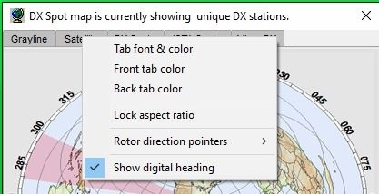

TW_1

See the Grayline, Satellite, DX Spots, IOTA or View DX panel sections for more detail.

The active and non-active tab colors can be selected as well as the font and text color.

The aspect ratio of any of the maps can be locked to a standard format by checking the menu option. Note that this is a general option and therefore applies to all maps in the Tracking window.

The rotor direction pointer colors and line widths can be set up here. (See the Tracking Window paragraphs in the Setup Antenna Rotor topic and Background Maps paragraphs below for more information).

Note: For accurate rotor operation, the map display MUST be in "Azimuthal Equidistant" projection and have the "Lock aspect ratio" menu item checked.

Selecting the “Show digital heading” will open a floating window showing the antenna heading. See the Rotor Setup topic for details.

2.0 BACKGROUND MAPS

There are three basic options as to the type of map (and/or its source) to be used:

  - Computer-generated Miller projection;
  - Computer-generated Azimuth Equidistant projection (Great Circle); and,
  - User-supplied Miller projection.

For 1 and 2 above, there are various options that can be selected before generating the maps. Option 3 ONLY applies to the use of Miller projection maps.

The reader is advised to consult the topic Background Maps for more detail and to view some examples.

Note: The Great Circle maps do not automatically change their perspective if the user changes their QTH settings in Logger32. They must be re-drawn.

Great Circle versions of the maps in the Tracking window (except for the Satellite window) will have the capability of displaying information for the control of computer-controlled rotors. Two pointers are provided:

  - The setting of the desired antenna position; and,
  - Te actual position.

An example is given below:

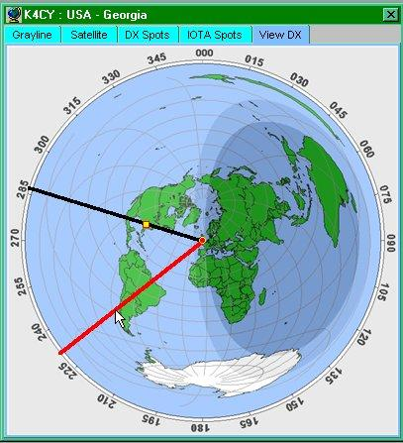

TW_2

In this particular example, the red line will control the desired direction (in conjunction with a mouse click) and the black line will be the actual antenna bearing (in real time). More information on this can be found in the Setup Antenna Rotator topic.

3.0 GRAYLINE PANEL

The Grayline panel overlays the world map with three distinct shaded areas defining:

  - Day;
  - Night: and,
  - A selectable transition area between day and night (the Grayline).

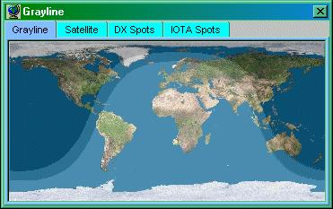

TW_3

A right-click on this window will display a pop-up menu allowing the operator to:

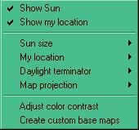

TW_4

  - Show or hide the sun;
  - Show or hide your QTH marker;
  - Select the size of the sun displayed on the map from one of three sizes;
  - Set up color(s) and size of the QTH location marker;
  - Select the size of the Grayline.;

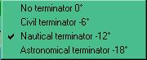

TW_5

  - Select the type of projection to use as the background map. Please see the topic Background Maps;
  - Select the contrast to be displayed between the three areas; and,
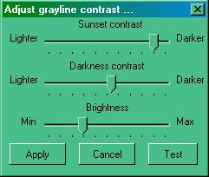
TW_6
  - Create Custom base maps.

The screen capture of the grayline panel displayed above (TW_3) is showing the daylight terminator set to nautical (-12 degrees). It also uses an external Miller map projection.

4.0 SATELLITE PANEL

The Satellite Panel overlays the world map with the optional display of the position, and the predicted track to next Acquisition of Signal (AOS) or Loss of Signal (LOS) of a selected satellite as well as optional details.

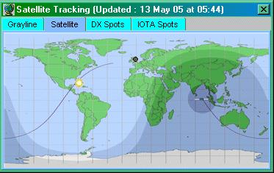

TW_7

The satellite to be displayed is selected from the drop-down list in the Satellite Data dialog box that will appear when the "Satellite" tab is selected.

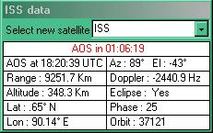

TW_8

Note 1: If this dialog box does not appear, then right-click on the satellite map and check "Show Satellite details".

Note 2: The information in this panel will ONLY be correct if you have ensured that:

  - Your QTH Lat/Long are set properly;
  - The Keplerian elements are up to date: and,

  - The computer clock is set correctly.

The satellites given in the Select new satellite drop-down list are derived from the import of one or more sets of Keplerian elements described later.

The remaining sections of the data panel show:

  - The time in hours, minutes, and seconds remaining until the next AOS or LOS [when the satellite reaches AOS, a new track is drawn from AOS to LOS and the time indicator on the top row changes to show the time remaining to LOS. Once LOS is reached, a new track will be drawn to the next AOS]

  - The azimuth and elevation of the satellite (Lat and Long must be set correctly)

  - The Lat/Long of the satellite

  - Additional information such as the range, Doppler shift, eclipse state, phase and orbit number

Right-clicking on the satellite map will display the pop-up menu shown below:

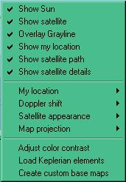

TW_9

4.1 Show Sun/Overlay grayline/Show my location/Show satellite/Show satellite path

Select this menu item to display each item on the map.

4.2 Show Satellite details

Select this menu item to display the Satellite Data dialog box.

4.3 My Location

Select this menu item to select the preferred colors and/or size of the QTH marker

4.4 Doppler shift

Select this menu item to change the Doppler shift value displayed in the Satellite Data dialog box. This value can be based on frequencies in the 10M, 2M, 70 or 23 cm bands.

4.5 Satellite Appearance

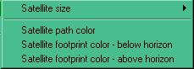

TW_10

4.5.1 Satellite size

Display the satellite in one of three sizes.

4.5.2 Satellite path color

Select the preferred color for the satellite path.

4.5.3 Satellite footprint color

Set different footprint colors depending on the position of the satellite. The footprint will show the satellite above the horizon when your QTH is contained within the footprint area.

4.6 Adjust color contrast

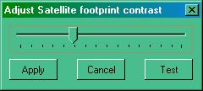

TW_11

Note: The contrast settings for the grayline, the footprint contrast and the colors of the underlying map all contribute to how well or otherwise these colors/settings actually display on your screen. It is recommended that you stick to a darker range of colors for the footprint.

4.7 Load Keplarian elements

See below.

4.8 Map projection/Create custom base map

See the topic Background Maps.

5.0 LOAD KEPLARIAN ELEMENTS

Right-click on the Satellite map and select the Load Keplerian elements menu item to display the Load Keplarian elements dialog box.

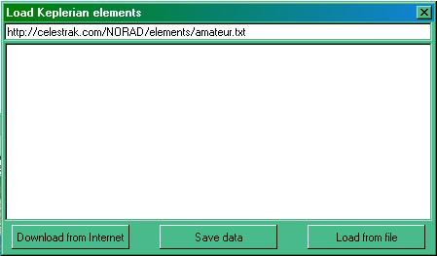

TW_12

From here you can load elements from the web or from a file you may already have on your computer. Note that the files MUST have the extension of .TXT.

If you download from the Internet, you can change the default location and file before selecting the <Download from Internet> button. The file contents will appear in the display portion of the window.

If you wish to load a file from the computer, select the <Load from file> button and you will be presented with the Windows FIle Open dialog box. Make your selection and select the <Open> button. The file contents will appear in the display portion of the window.

Select the <Save data> button and you will be advised on how many satellite elements have been loaded and you will be given the choice to save these to memory. To save the file, select the <Yes> button and the data will be saved in a file called KEPS.TXT in the default Logger32 directory.

Logger32 will accept a maximum of 100 element sets.

[The correspondence below is supplied for information. Thanks are given to both Eddie and Thom in allowing this to be reproduced here. The source was the Hamlogger reflector 8th April 2005]

On Fri, 08 Apr 2005 18:55:10 +0000, WI8W wrote:
> For those that do not know...
>
> when updating keps be aware that some websites that carry the updated
> keps are no longer allowed to distribute updated elements under the
> order of the US Government. It's a security issue from what I undestand.(sic)
>
> I used to get my keps from www.celestrak.com but they are one that is
> not allowed to provide updates. I was directed by that site to
> www.space-track.org. This is the official site for keps that is
> authorized to distribute them. You have to sign up for a free account.
> I assume that they actually do some slight background checking before
> they OK the account. Mine (sic) application took 3 days to be approved.
>
Further, you can get your account at space track then go to Dr. Kelso's
www.celestrak.com site, click on the "current data" box, then click on the
"Space Track TLE Retriever" line and use this application to automatically
login to Space Track and retrieve current keps. The TLE Retriever will
reformat the keps to a .txt file that Logger32 can directly load. Works
very well here.
--
Eddie, WB4MLE

Before these predictions will be correct for your location, you MUST ensure that your own latitude and longitude have been entered into Logger32. See the topic Setup User Lat and Long.

6.0. DX SPOTS PANEL

Incoming DX Spots are displayed on the DX Spots Map. The square markers are the spots and the round marker is your home location. The colors and sizes of both types of marker can be defined by the user.

The background map may be changed by right-clicking on the DX Spots map and selecting the Create custom base maps menu item..

Left-clicking on a map marker is the same as left-clicking on an entry in the DX Spots window, i.e., the radio will QSY. Mouseover Hints are provided.

6.1 Operation

When spots are being received, the DX Spot map will become populated.

A Hint box will be displayed as the cursor is passed over each spot. This Hint shows the:

  - Callsign of the station making the report;
  - Callsign of the station heard;
  - Frequency;
  - Prefix;
  - Country name;
  - Zone;
  - Continent;
  - Worked/Confirmed status; and,
  - Time duration of the spot.

Note: Some of this information depends on the settings in the Band/Mode table and the content of your log.

Currently the maximum number of spots on the map is 99. Any new spots will be displayed, removing older spots.

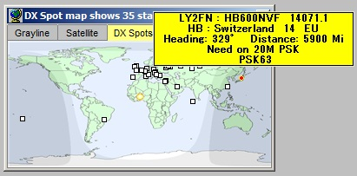

New TW_15

Right-clicking anywhere on the map will produce the setup menu shown below:

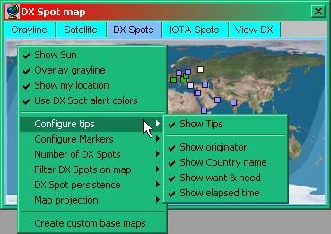

TW_16

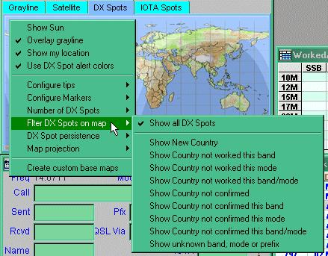

TW_17

6.2 Show Sun

Check to display the position of the sun.

6.3 Overlay Grayline

Check to turn on the grayline.

6.4 Show my location

Check to display your location (colored circle).

6.5 Use DX Spot alert colors

Check to use the colors set up in the Worked/Confirmed color selection.

Note: If this is left un-checked, then the marker color will be determined by the setting under "Marker fixed color" in the Configure Markers option.

6.6 Configure tips

Select the Show tips menu item to show the mouseover tooltips on the DX Spots map. Once checked you can then select any combination of:

  - Show heading;
  - Show originator;
  - Show comments;
  - Show elapsed time;
  - Show country name; and
  - Show want & need.

6.7 Configure Markers

Select the colors for the various markers and borders and a size to be used by all markers. A range of four marker sizes is available.

Note: The fixed marker color is used to display DX Spots which do not meet any of the colored background criteria.

6.8 Number of DX Spots

Select all (99), 50, 40, 30, 20, 10, or just 5 of the latest spots received.

Note 1 - The "Show all" spots marker has a max of 99. The actual number of spots on the map is 99 minus announce, talk, WWV, WCY, etc. Show (say) 50 spots actually shows 50 minus announce, WWV, WCY, etc. The number you select is the last x entries in the DX Spot window.

Note 2 - If you use (say) show 5 spots, and they are all for the same station, it will look like there's only one marker on the map when actually there are 5, but all on top of each other.

Note 3 - One other example: Show (say) 5 and the last 5 entries in the DX Spots window are announce messages; there will be no markers on the map.

6.8 Filter DX Spots on map

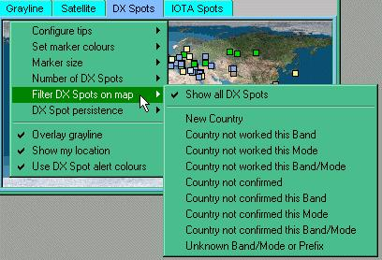

TW_18

The user can selectively display spots as listedon the pop-up menu.

Note 1: If you want to display all spots but NOT ones where you have the country/band/mode fully confirmed, then check all the selections rather than "show all DX spots".

Note 2: If you have selected "Show all DX Spots", fully confirmed country/band/mode spots will show. The default color for these particular spots will be the default set under the "Set marker color" menu option. In order to distinguish between these particular spots and others, then it is suggested that you set the default marker color to one that you do not use in the "Worked/Confirmed" range.

6.9 Overlay Grayline

Check to turn on the grayline.

6.10 DX Spot persistence

Select the preferred time for the displayed spots to remain visible.

6.11 Show my location

Check to display your location (colored circle).

6.12 Use DX Spot alert colors

Check to use the colors set up in the Worked/Confirmed color selection.

7.0 IOTA SPOT PANEL

Incoming IOTA Spots are displayed on the IOTA Spots Map. The square markers are the spots and the round marker is your home location. The colors and sizes of both types of marker can be defined by the user.

The background map may be changed by right-clicking on the IOTA Spot Map itself.

Left-clicking on a map marker is the same as left-clicking on an entry in the DX Spots window, i.e., the radio will QSY. Mouseover hints are provided. There is one major difference however. Clicking on an IOTA spot (from the map) will populate the IOTA edit box in the Logbook Entry Window if it is in use. Clicking on the DX Spot (from the DX Spot map) WILL NOT fill in the IOTA edit box.

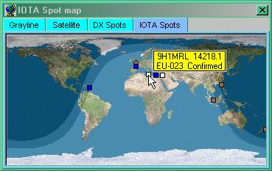

TW_19

7.1 Operation

When spots are being received, the IOTA Spot map will become populated from either information collected from the comments fields in the incoming data OR from the received callsign IF the prefix is also uniquely an IOTA reference.

A note of caution: Logger32 does its best to extract the IOTA information from the DX spots, but there will be occasions where this will fail OR it will pick up erroneous information. It is up to the operator to make sure that logged data is correct.

A mouseover Hint will be displayed as the cursor is passed over each spot. This Hint displays the:

  - Callsign of the person making the report;
  - Callsign of the station heard;
  - Frequency;
  - Prefix;
  - Country name;
  - Zone;
  - Continent;
  - IOTA Island name; and
  - Whether it is a station required for the log.

Right-clicking anywhere on the map will produce the setup menu as shown below:

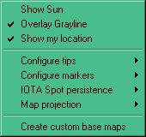

TW_20

7.2 Show Sun

Check to show the position of the sun.

7.3 Overlay Grayline

Check to turn on the grayline.

7.4 Show my location

Check to display your location (colored circle).

7.5 Configure Tips

Select the Show tips menu item to show the mouseover Hints on the DX Spots map. Once checked you can then select any combination of:

  - Show heading;
  - Show originator;
  - Show comments;
  - Show elapsed time;
  - Show country name; and,
  - Show want and need.

7.6 Configure Markers

Select the colors for the various markers and a size to be used by all markers. A range of four marker sizes is available.

The Set marker colors menu item allows the user to set the marker colors based on Worked, Confirmed, Submitted and Granted.

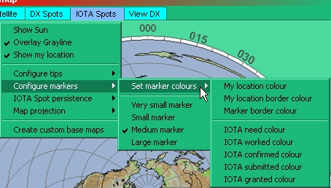

TW_24

7.7 IOTA Spot persistence

Select the preferred time for the displayed spots to remain visible.

7.8 Map Projection

See the topic "Background Maps.

7.9 Important Note on IOTA Tooltips

Logger32 does its best to retrieve the IOTA information from the DX spot comment field, but this is not always in the correct format. Logger32 will correct for many of the common mistakes and when it does so, it will place a "?" into the tooltip in order to draw the operator's attention to the fact that the data may not be correct.

8.0 VIEWS DX PANEL

The View DX Panel is designed to display information, which is already available on the computer (the DX Spot Panel displays information derived from some outside source). Currently it will show one of two things on the map, the location of:

  - An entered prefix (or full callsign); and,
  - The center of a specified IOTA Group.

To use either of these capabilities it is not necessary to have the Tracking window loaded (it will load automatically). If the Tracking window is loaded, the tab will automatically switch to the View DX tab.

Like all other maps in the Tracking Window you can select one of two forms of presentation. Refer to the topic Background Maps.

8.1 To Display the Location of a Prefix

The View DX tab of the Tracking window has a "real time" feel based on what is entered into the Logbook Entry window Callsign field, provided that the tab is already open. Simply enter a callsign or prefix into the Logbook Entry window and the location will show up immediately on the selected map.

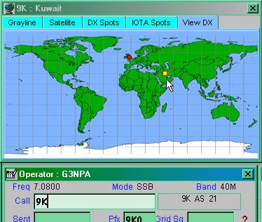

TW_21

An additional shortcut, the <Ctrl+V> keys has been added to the Logbook Entry window menu. If a callsign is entered, selecting the <Ctrl+V> keys will show the location of the station on the View tab of the Tracking window. If you are not displaying the View DX map at the time, Logger32 will bring up the correct display.

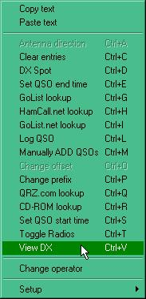

TW_22

8.2 To Display the Location of a Specified IOTA Group

From the IOTA search list (see Additional Information), simply highlight the island group you wish to view. If the map doesn't immediately appear, then try right-clicking on the <Show> button.

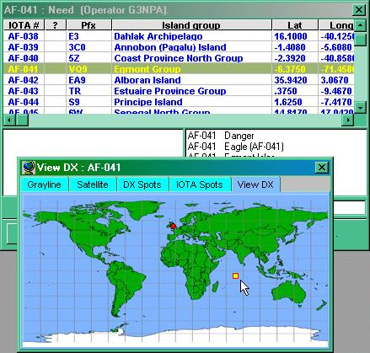

TW_23

